Project Development Phase
Model Performance Test
Date | September 2026
Project Name | ServiceNow-Based Employee Laptop Request Application

Model Performance Testing:
Project team shall fill the following information in the model performance testing template. For this project, the solution is a ServiceNow-based employee laptop request workflow and does not contain an AI/ML prediction model. Therefore, model-specific accuracy and fine-tuning metrics are marked as Not Applicable (N/A). These fields can be edited if an AI/ML component is added later.

S.No. | Parameter | Values | Screenshot
1. | Model Summary | ServiceNow-based Employee Laptop Request Application.  Purpose: submit laptop requests, capture required details, route approvals, track request status, check asset availability, send notifications, and support IT fulfilment.  AI/ML model used: N/A. | 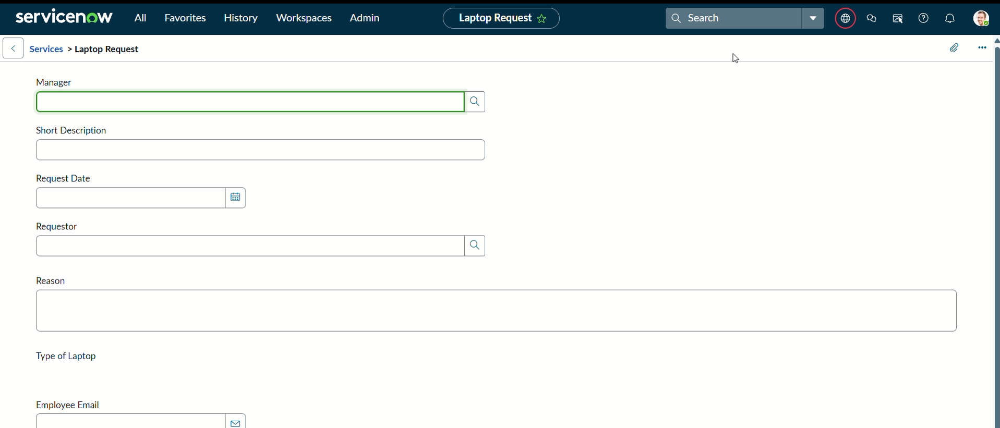
2. | Accuracy | Training Accuracy – N/A  Validation Accuracy – N/A  Reason: the project is a workflow/request-management application rather than a machine-learning model. | 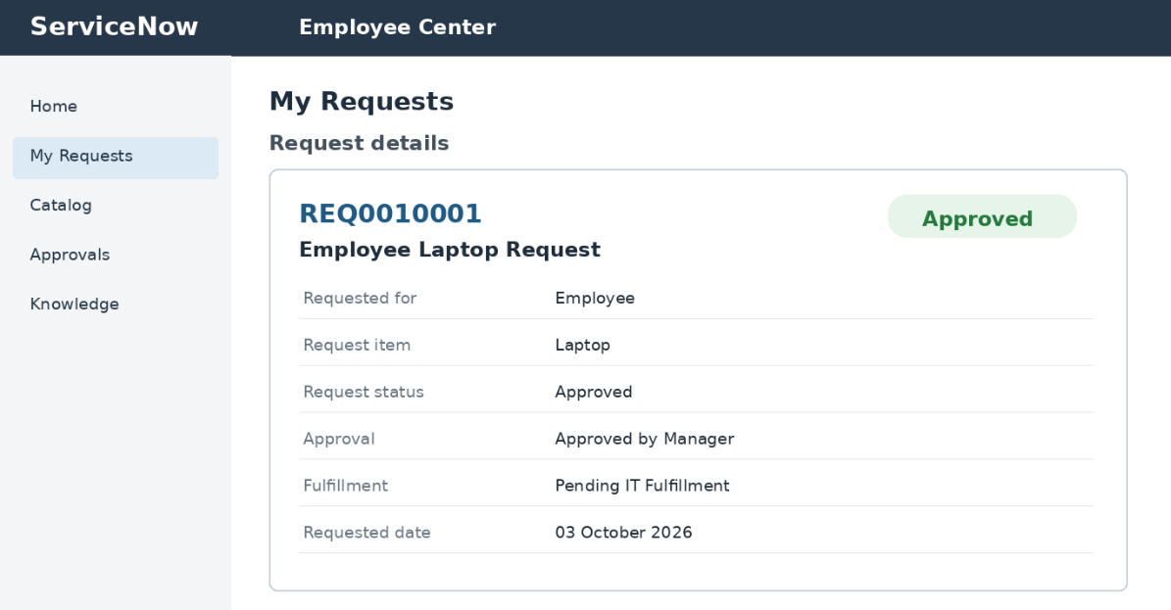
3. | Fine Tuning Result (if Done) | Validation Accuracy – N/A  Fine-tuning – Not Applicable because no AI/ML model is part of the proposed solution.  If an AI/ML feature is implemented later, enter the pre- and post-tuning validation results here. | 